**Project Design Phase-II**

**Data Flow Diagram & User Stories**

|  |  |
| --- | --- |
| Date | 28 January 2025 |
| Team ID | LTVIP2025TMID59298 |
| Project Name | **BookNest: Where Stories Nestle** |
| Maximum Marks | 4 Marks |

**Data Flow Diagrams:**

A Data Flow Diagram (DFD) is a traditional visual representation of the information flows within a system. A neat and clear DFD can depict the right amount of the system requirement graphically. It shows how data enters and leaves the system, what changes the information, and where data is stored.

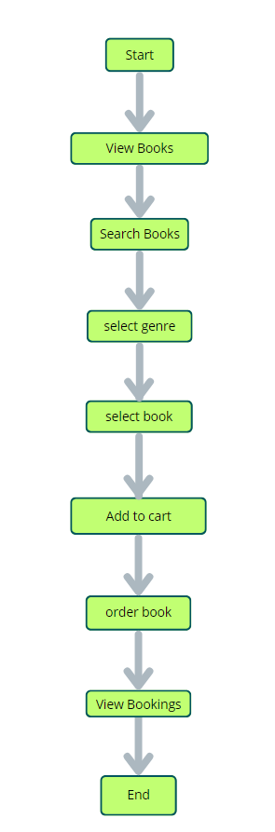

User Stories

**User Type:** Customer (Web User)

| **Functional Requirement (Epic)** | **User Story Number** | **User Story / Task** | **Acceptance Criteria** | **Priority** | **Release** |
| --- | --- | --- | --- | --- | --- |
| Registration | USN-1 | As a user, I can register for the application by entering my email, password, and confirming my password. | I can access my account / dashboard | High | Sprint-1 |
| Registration | USN-2 | As a user, I will receive confirmation email once I have registered for the application | I can receive confirmation email & click confirm | High | Sprint-1 |
| Registration | USN-3 | As a user, I can register for the application through Facebook | I can register & access the dashboard with Facebook Login | Low | Sprint-2 |
| Registration | USN-4 | As a user, I can register for the application through Gmail | I can register using Gmail OAuth | Medium | Sprint-1 |
| Login | USN-5 | As a user, I can log into the application by entering email & password | I can securely access my dashboard | High | Sprint-1 |
| Book Purchase | USN-6 | As a user, I can browse and purchase books | I can view, select, and place an order for books | High | Sprint-2 |
| Profile | USN-7 | As a user, I can view and update my profile information | My changes are saved and visible after update | Medium | Sprint-2 |

**User Type: Seller**

| **Functional Requirement (Epic)** | **User Story Number** | **User Story / Task** | **Acceptance Criteria** | **Priority** | **Release** |
| --- | --- | --- | --- | --- | --- |
| **Book Management** | **USN-8** | **As a seller, I can add new books with title, price, and image** | **The book appears in my listings after adding** | **High** | **Sprint-1** |
| **Book Management** | **USN-9** | **As a seller, I can edit and delete my listed books** | **I can update or remove any of my books** | **High** | **Sprint-1** |
| **Order Tracking** | **USN-10** | **As a seller, I can view orders placed on my books** | **I can see order details like customer and status** | **Medium** | **Sprint-2** |
| **Profile** | **USN-11** | **As a seller, I can view my profile and update contact info** | **Updated info should reflect on my profile** | **Low** | **Sprint-3** |

**User Type: Administrator**

| **Functional Requirement (Epic)** | **User Story Number** | **User Story / Task** | **Acceptance Criteria** | **Priority** | **Release** |
| --- | --- | --- | --- | --- | --- |
| **User Management** | **USN-12** | **As an admin, I can view all users and their roles** | **I can manage users from the admin panel** | **Medium** | **Sprint-3** |
| **Content Moderation** | **USN-13** | **As an admin, I can manage inappropriate books or users** | **I can disable or delete content as needed** | **Medium** | **Sprint-3** |